2-7-16
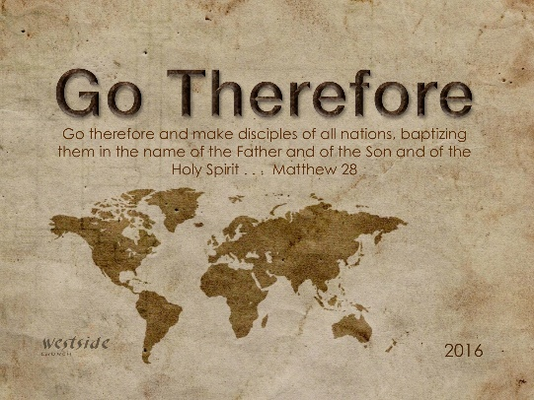

Living A Life Ready To Go

Mark 1:16-20 (ESV)
¹⁶ Passing alongside the Sea of Galilee, he saw Simon and Andrew the brother
Of Simon casting a net into the sea, for they were fishermen.
¹⁷ And Jesus said to them, “Follow me, and I will make you become fishers of men.”
¹⁸ And immediately they left their nets and followed him.
¹⁹ And going on a little farther, he saw James the son of Zebedee and John his brother, who were in their boat mending the nets.
²⁰ And immediately he called them, and they left their father Zebedee in the boat with the hired servants and followed him.

Mark 2:13-17 (ESV)
¹³ He went out again beside the sea, and all the crowd was coming to him, and he was teaching them.
¹⁴ And as he passed by, he saw Levi the son of Alphaeus sitting at the tax booth, and he said to him, “Follow me.” And he rose and followed him.
¹⁵ And as he reclined at table in his house, many tax collectors and sinners were reclining with Jesus and his disciples, for there were many who followed him.
¹⁶ And the scribes of the Pharisees, when they saw that he was eating with sinners and tax collectors, said to his disciples, “Why does he eat with tax collectors and sinners?”
¹⁷ And when Jesus heard it, he said to them, “Those who are well have no need of a physician, but those who are sick. I came not to call the righteous, but sinners.”

Intro
- We don’t have to be good enough to be called. Jesus came to save sinners. He calls us in the state that we are.
- Not all of us are called to move and plant a church or be missionaries, but there are other ways we can go.
- What we are called to do will seem crazy to others.

Going

- Why would we go?
- What that looks to be ready to go.

Staying

- Go looks different when we are called to stay.
- Why are we staying?
- There are still changes that we will make to be ready to stay.

Acts 11:11-17 (ESV)
¹¹ And behold, at that very moment three men arrived at the house in which we were, sent to me from Caesarea.
¹² And the Spirit told me to go with them, making no distinction. These six brothers also accompanied me, and we entered the man’s house.
¹³ And he told us how he had seen the angel stand in his house and say, ‘Send to Joppa and bring Simon who is called Peter;
¹⁴ he will declare to you a message by which you will be saved, you and all your household.’
¹⁵ As I began to speak, the Holy Spirit fell on them just as on us at the beginning.
¹⁶ And I remembered the word of the Lord, how he said, ‘John baptized with water, but you will be baptized with the Holy Spirit.’
¹⁷ If then God gave the same gift to them as he gave to us when we believed in the Lord Jesus Christ, who was I that I could stand in God’s way?”

What is the result?

- Weather we are called to go, or to say the impact should be the same.
- When we say yes to God the Kingdom is advanced, and the Good news is spread.
- If God told us to go are we ready, and willing?

