10-16-16
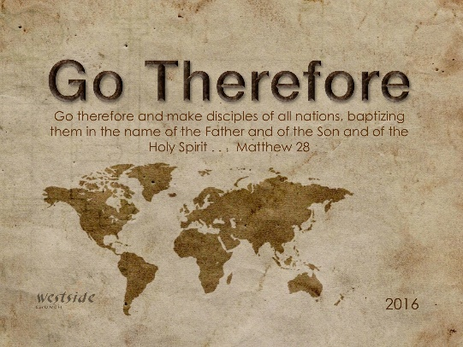

Being a Disciple of Jesus

Matthew 28:18-20 (NLT)
¹⁸ Jesus came and told his disciples, “I have been given all authority in heaven and on earth. ¹⁹ Therefore, go and make disciples of all the nations, baptizing them in the name of the Father and the Son and the Holy Spirit. ²⁰ Teach these new disciples to obey all the commands I have given you. And be sure of this: I am with you always, even to the end of the age.”

- Becoming Like His _________________ or Master
Luke 6:40 (NLT)
⁴⁰ Students are not greater than their teacher. But the student who is fully trained will become like the teacher.

- You are a ________________ of Jesus

- Corinthians 11:12 (NLT)
¹² But I will continue doing what I have always done. This will undercut those who are looking for an opportunity to boast that their work is just like ours.

- You are becoming like __________________

- Becoming Like Jesus

- Becoming Like Jesus in ___________________

2 Corinthians 3:18 NLT)
¹⁸ So all of us who have had that veil removed can see and reflect the glory of the Lord. And the Lord—who is the Spirit—makes us more and more like him as we are changed into his glorious image.

- __________________

Philippians 2:5-8 (NLT)
⁵ You must have the same attitude that Christ Jesus had. ⁶ Though he was God, he did not think of equality with God as something to cling to. ⁷ Instead, he gave up his divine privileges; he took the humble position of a slave and was born as a human being. When he appeared in human form, ⁸ he humbled himself in obedience to God and died a criminal’s death on a cross.

- ______________________

- Becoming Like Jesus in Relationship with the Father
Matthew 4:4 (NLT)
⁴ But Jesus told him, “No! The Scriptures say, ‘People do not live by bread alone, but by every word that comes from the mouth of God.’”

- God is a God Who _______________

- His Kingdom is ___________________

- Life Flows from ________________

- Becoming Like Jesus in ________________
John 14:12 (NLT)
¹² “I tell you the truth, anyone who believes in me will do the same works I have done, and even greater works, because I am going to be with the Father.

  - _________ Picture

  - Make _______________

  - Plant ______________

  - _________ Nations

Application

- He is Saying Today, “Come, Follow Me.”

- “This is My Desire, to Honor You”

- Empowering of the Spirit

Response:
What is God speaking to me?

Specifically, how will I obey Him?

