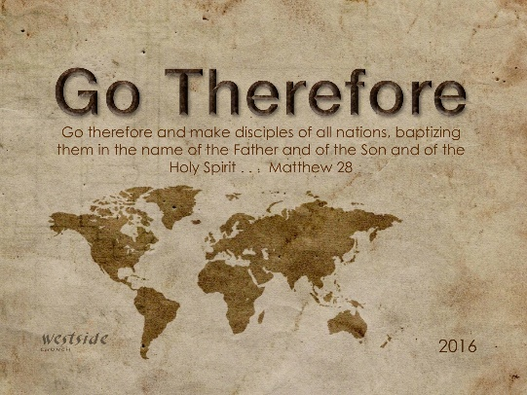
11-6-16

Romans #10

Yep . . . I’m A Sinner

What The Bible Says

Romans 3:9-20
Well then, should we conclude that we Jews are better than others? No, not at all, for we have already shown that all people, whether Jews or Gentiles, are under the power of sin. ¹⁰ As the Scriptures say, “No one is righteous— not even one. ¹¹ No one is truly wise; no one is seeking God. ¹² All have turned away; all have become useless. No one does good, not a single one.” ¹³ “Their talk is foul, like the stench from an open grave. Their tongues are filled with lies.” “Snake venom drips from their lips.” ¹⁴ “Their mouths are full of cursing and bitterness.” ¹⁵ “They rush to commit murder. ¹⁶ Destruction and misery always follow them. ¹⁷ They don’t know where to find peace.” ¹⁸ “They have no fear of God at all.” ¹⁹ Obviously, the law applies to those to whom it was given, for its purpose is to keep people from having excuses, and to show that the entire world is guilty before God. ²⁰ For no one can ever be made right with God by doing what the law commands. The law simply shows us how sinful we are.

1. Everyone – Everywhere – Everywhen – outside of Jesus is under the _________ __ _____

To the question of whether there was any value in being a Jew, Paul had said yes (3:2). But to the question as to whether Jews are better than Gentiles, Paul answers no. The reason? Jews and Gentiles alike are all under sin. Both need God's grace. Gentiles have no excuse (1:20), and neither do Jews (2:1).
-labc

2. Seriously, no one is good – in and of themselves . . .

How well do we _________________ God? (3:11)

How diligently are we ________________ God? (3:11)

How much ________________ would God find in our daily life? (3:12)

In the wake of our actions and words, do we leave people helped or _____________? (3:13-15)

What is our record of _____________________? (3:17)

In what sense do we__________ God? (3:18)

Paul's point here is that
an honest look at the facts of sinfulness
will inevitably bring us to the conclusion
that every human being
is under the judgment of Almighty God.

Application

“Hard truth is better than sweet deceit.”

The Law is our teacher . . .

- First: the law shows us ______________ we go wrong.

- Second, the morals we see in the law can help _________ our actions.

The only way God can get glory from a human being is that they truly repent, give up their life and live for Him and let God fill them with His presence.

My only reason for being is the glory of God!

So now what?

Matthew 13:20-23 (NLT)
²⁰ The seed on the rocky soil represents those who hear the message and immediately receive it with joy. ²¹ But since they don’t have deep roots, they don’t last long. They fall away as soon as they have problems or are persecuted for believing God’s word. ²² The seed that fell among the thorns represents those who hear God’s word, but all too quickly the message is crowded out by the worries of this life and the lure of wealth, so no fruit is produced. ²³ The seed that fell on good soil represents those who truly hear and understand God’s word and produce a harvest of thirty, sixty, or even a hundred times as much as had been planted!”

1. If you’ve seen the enormity of your sin and have truly repented – thank God!

2. If you haven’t repented – truly repented – please do so now.
- trust in what Jesus did for you and turn your life over to him.

3. If you have received Christ by faith – ask Him to sustain and keep you – each day – each moment keep Jesus in the forefront – the center! Keep Him first!

Response:

What is God speaking to me?

Specifically, how will I obey Him?

