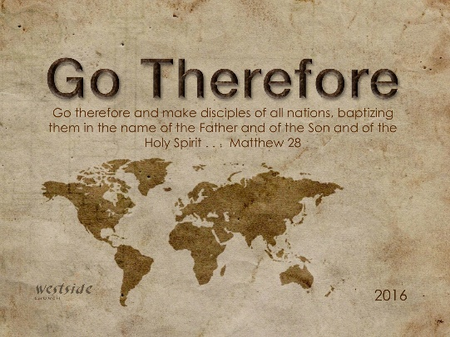
11-27-16
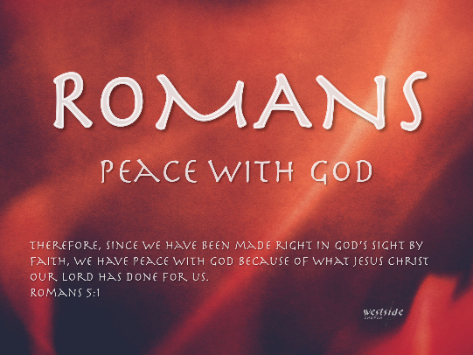

Romans #13

Peace With God

What The Bible Says

Romans 5:1-2
Therefore, since we have been made right in God’s sight by faith, we have peace with God because of what Jesus Christ our Lord has done for us. ² Because of our faith, Christ has brought us into this place of undeserved privilege where we now stand, and we confidently and joyfully look forward to sharing God’s glory.

1. True peace will not come until we are made right in ______ ___________

vs 1: Therefore, since we have been made right in God’s sight by faith, we have peace with God

A person who is justified...
- stands in God's presence.
- stands before God saved.
- stands in the favor of God.
- stands in the privileges of God.
- stands in the promises of God.
Peace with God means the sense and knowledge...
- that a person has restored their relationship with God.
- that a person is no longer alienated and separated from God.
- that a person is now reconciled with God.
- that a person is now accepted by God.
- that a person is freed from the wrath and judgment of God.
- that a person is freed from fearing God's wrath and judgment.
- that a person is now pleasing God.
- that a person is at peace with God.

2. True peace is only possible because of what _____________ has done for us.

vs 1: we have peace with God because of what Jesus Christ our Lord has done for us

Jesus’ death and resurrection
completes God’s plan
to redeem mankind.

3. True peace is only possible when we truly _____________ what Jesus has done for us.

vs 2: . . .because of our faith, Christ has brought us into this place . . .

Blood-bought covenantal intimacy
with God for sinners through Jesus.

4. True peace is only possible because of God’s ____________.

vs 2: this place of undeserved privilege where we now stand

Undeserved wretches
find redemption
at the cross.

Application

1. True peace with God is only possible when we truly believe what Jesus has done and humbly _______________God’s grace.

vs 1-2: Therefore, since we have been made right in God’s sight by faith, we have peace with God because of what Jesus Christ our Lord has done for us. ² Because of our faith, Christ has brought us into this place of undeserved privilege where we now stand.

God made it.
Humans broke it.
Jesus fixed it!

2. True peace with God made possible when by faith we receive God’s grace will result in a confident and ______________ life.

vs 2: and we confidently and joyfully look forward to sharing God’s glory.

Therefore, since we have been made right
in God’s sight by faith,
we have peace with God
because of what Jesus Christ
our Lord has done for us.

Response:
What is God speaking to me?

Specifically, how will I obey Him?

