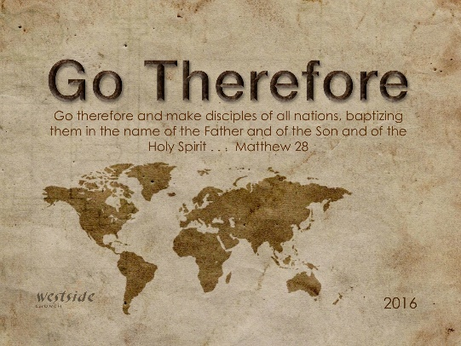
12-4-16
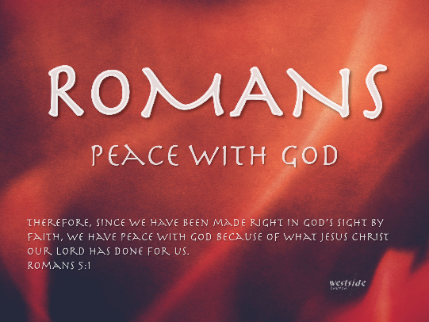

Romans #14

Joy In Trouble

What The Bible Says

Romans 5:1-5
Therefore, since we have been made right in God’s sight by faith, we have peace with God because of what Jesus Christ our Lord has done for us. ² Because of our faith, Christ has brought us into this place of undeserved privilege where we now stand, and we confidently and joyfully look forward to sharing God’s glory. ³ We can rejoice, too, when we run into problems and trials, for we know that they help us develop endurance. ⁴ And endurance develops strength of character, and character strengthens our confident hope of salvation. ⁵ And this hope will not lead to disappointment. For we know how dearly God loves us, because he has given us the Holy Spirit to fill our hearts with his love.

Keeping Your Joy In A Stressful Season

1. Keep Your ___________________ In Order

A. Put God and His Agenda _____________

Matthew 6:33 (NLT)
He will give you all you need from day to day if you live for him and make the Kingdom of God your primary concern.

B. Choose Your _____________________ Wisely

One of the devil’s most destructive devices is to
get us off track by diluting our focus, dissipating
our strength, distracting us, and to causing us to spend our time and energy on that which God never intended us to do.
-sb

Matthew 28:19
Therefore, go and make disciples of all the nations, baptizing them in the name of the Father and the Son and the Holy Spirit.

C. Use Your _______________ Wisely

1 Peter 4:7-9 (NLT)
The end of the world is coming soon. Therefore, be earnest and disciplined in your prayers. ⁸ Most important of all, continue to show deep love for each other, for love covers a multitude of sins. ⁹ Cheerfully share your home with those who need a meal or a place to stay.

"The world has yet to see
what God can do
with
and for
and through
and in
a person who is fully
and wholly consecrated to Him."
-Henry Varley

2. Bring Your ____________________ Closer Together

“No one on their deathbed wishes they spent
more time at the office”

Deut. 26:11
Afterward go and celebrate because of all the good things the Lord your God has given to you and your household. Remember to include the Levites and the foreigners living among you in the celebration.

3. Restore A _____________________ Relationship

Ephesians 4:31-32 (NIV)
Get rid of all bitterness, rage and anger, brawling and slander, along with every form of malice. Be kind and compassionate to one another, forgiving each other, just as in Christ God forgave you.

4. Don’t Forget To Give God Your ________________ Gift

2 Samuel 24:24 (NIV)
"No, I insist on paying you for it. I will not sacrifice to the Lord my God offerings that cost me nothing."

"Forgiveness is to set a prisoner free,
and to realize the prisoner was you."
-Corrie Ten Boom

Finally:

Luke 2:8-14 (NKJV)
Now there were in the same country shepherds living out in the fields, keeping watch over their flock by night. ⁹ And behold, an angel of the Lord stood before them, and the glory of the Lord shone around them, and they were greatly afraid. ¹⁰ Then the angel said to them, "Do not be afraid, for behold, I bring you good tidings of great joy which will be to all people. ¹¹ For there is born to you this day in the city of David a Savior, who is Christ the Lord. ¹² And this will be the sign to you: You will find a Babe wrapped in swaddling cloths, lying in a manger." ¹³ And suddenly there was with the angel a multitude of the heavenly host praising God and saying: ¹⁴ "Glory to God in the highest, And on earth peace, goodwill toward men!"

Matthew 5:16 (KJV)
Let your light so shine before men, that they may see your good works, and glorify your Father which is in heaven.

Response:

What is God speaking to me?

Specifically, how will I obey Him?

