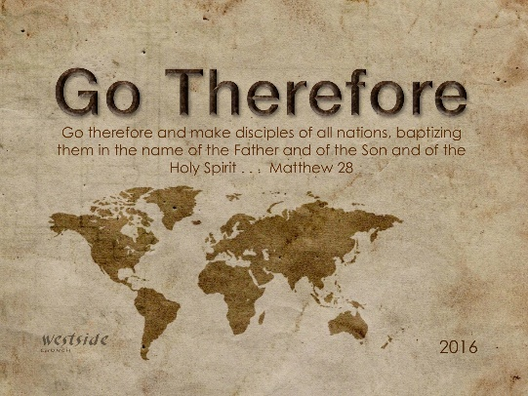
12-18-16
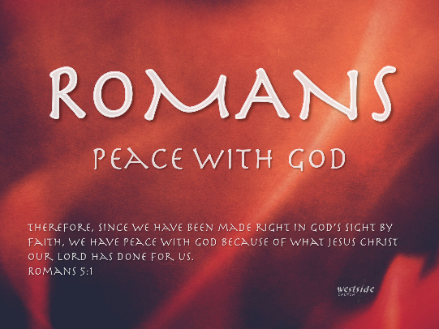

Romans #15

At Just The Right Time

What The Bible Says

Romans 5:6-11
When we were utterly helpless, Christ came at just the right time and died for us sinners. ⁷ Now, most people would not be willing to die for an upright person, though someone might perhaps be willing to die for a person who is especially good. ⁸ But God showed his great love for us by sending Christ to die for us while we were still sinners. ⁹ And since we have been made right in God’s sight by the blood of Christ, he will certainly save us from God’s condemnation. ¹⁰ For since our friendship with God was restored by the death of his Son while we were still his enemies, we will certainly be saved through the life of his Son. ¹¹ So now we can rejoice in our wonderful new relationship with God because our Lord Jesus Christ has made us friends of God.

TWO WEEKS AGO:
Keeping Your Joy In A Stressful Season

1. Keep Your Priorities In Order

2. Bring Your Family Closer Together

3. Restore A Broken Relationship

4. Don’t Forget To Give God Your Best Gift

THIS WEEK:

1. God’s timing is ________________.

Verse 6: When we were utterly helpless, Christ came at just the right time and died for us sinners.

Galatians 4:4
But when the right time came, God sent his Son, born of a woman, subject to the law.

Ecclesiastes 3:11
Yet God has made everything beautiful for its own time. He has planted eternity in the human heart, but even so, people cannot see the whole scope of God’s work from beginning to end.

Q: Can we trust God’s timing?

2. God didn’t just SAY He Loves us – He ___________ He loves us.

Verse 8: But God showed his great love for us by sending Christ to die for us while we were still sinners.

In a detectable way?

Q: Can we do the same and demonstrate God’s love toward others?

3. God made the ___________ ____________ toward friendship.

Verse 8: For since our friendship with God was restored by the death of his Son while we were still his enemies, we will certainly be saved through the life of his Son.

It’s not always easy to make the first move:
what can get in our way?

Q: Can we swallow our pride and make the first move toward reconciliation or friendship?

Finally:

Why on earth can’t we be full of _______?!!

Verse 11: So now we can rejoice in our wonderful new relationship with God because our Lord Jesus Christ has made us friends of God.

Why can’t Believers be the happiest – most joy-filled people around?

AS LONG AS WE’RE POINTING PEOPLE TO ______________!!

Matthew 5:16 (ESV)
¹⁶ In the same way, let your light shine before others, so that they may see your good works and give glory to your Father who is in heaven.

Response:

What is God speaking to me?

Specifically, how will I obey Him?

