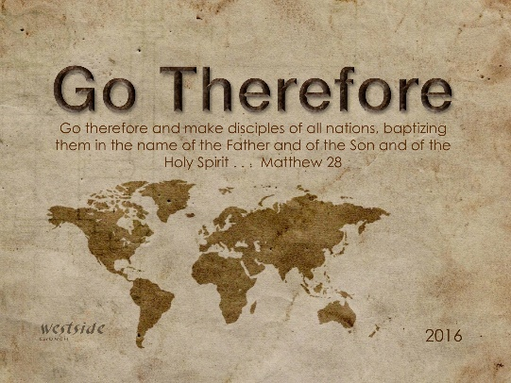
12-24-16
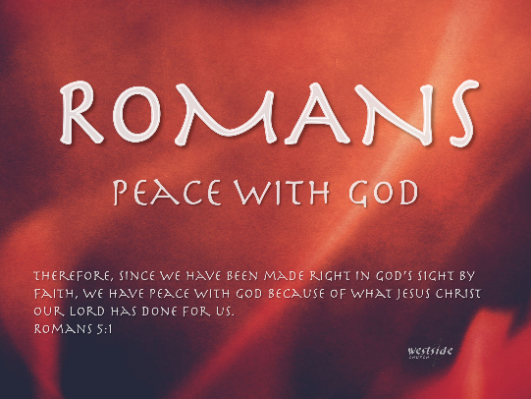

Romans #16

Peace With God For All Who Receive It

What The Bible Says

Romans 5:15-17
. . . there is a great difference between Adam’s sin and God’s gracious gift. For the sin of this one man, Adam, brought death to many. But even greater is God’s wonderful grace and his gift of forgiveness to many through this other man, Jesus Christ. ¹⁶ And the result of God’s gracious gift is very different from the result of that one man’s sin. For Adam’s sin led to condemnation, but God’s free gift leads to our being made right with God, even though we are guilty of many sins. ¹⁷ For the sin of this one man, Adam, caused death to rule over many. But even greater is God’s wonderful grace and his gift of righteousness, for all who receive it will live in triumph over sin and death through this one man, Jesus Christ.

Romans 5:1
Therefore, since we have been made right in God’s sight by faith, we have peace with God because of what Jesus Christ our Lord has done for us.

Isaiah 9:6
For unto us a child is born, unto us a son is given: and the government shall be upon his shoulder: and his name shall be called Wonderful, Counselor, The mighty God, The everlasting Father, The Prince of Peace.

True peace is not the lack of conflict between men
but the lack of conflict between men and God

PEACE WITH GOD:

Romans 5:1
Therefore, since we have been made right in God’s sight by faith, we have peace with God because of what Jesus Christ our Lord has done for us.

PEACE OF GOD:

Philippians 4:6-7
Be anxious for nothing, but in everything by prayer and supplication with thanksgiving let your requests be made known to God. And the peace of God, which surpasses all comprehension, will guard your hearts and your minds in Christ Jesus.

Rom 5:1 Therefore, since we have been made right in God’s sight by faith, we have peace with God because of what Jesus Christ our Lord has done for us.

How to have Peace “with” God
plan of salvation:
- believe
- surrender
- receive
- follow

John 3:16 (NKJV)
For God so loved the world that He gave His only begotten Son, that whoever believes in Him should not perish but have everlasting life.

Dear God,
I believe in you. There are a lot of things I don’t know about you – but I know you’re there. I believe Jesus came to die for the sin of the world . . . my sin. Please forgive me. I “receive” you now. Please lead my life from this point on. I give myself totally to you.
Thank you God for sending Jesus.
Thank you for saving me.
Thank you for making me your child.
Amen.

John 8:12
Jesus said “I am the light of the world. If you follow me, you won’t have to walk in darkness, because you will have the light that leads to life.”

Matthew 5:16
In the same way, let your light shine before others, so that they may see your good works and give glory to your Father who is in heaven.

