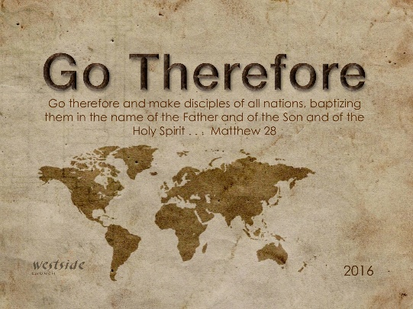
1-1-17
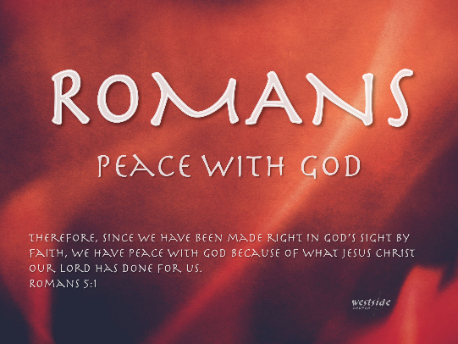

Romans #17

Raised To Life

Opening Comments
- Romans is about the Gospel
- The Gospel is about Jesus

What The Bible Says

Romans 5:20-21
God’s law was given so that all people could see how sinful they were. But as people sinned more and more, God’s wonderful grace became more abundant. ²¹ . . . now God’s wonderful grace rules instead, giving us right standing with God and resulting in eternal life through Jesus Christ our Lord.

Romans 6:1-11
Well then, should we keep on sinning so that God can show us more and more of his wonderful grace? ² Of course not! Since we have died to sin, how can we continue to live in it? ³ Or have you forgotten that when we were joined with Christ Jesus in baptism, we joined him in his death? ⁴ For we died and were buried with Christ by baptism. And just as Christ was raised from the dead by the glorious power of the Father, now we also may live new lives. ⁵ Since we have been united with him in his death, we will also be raised to life as he was. ⁶ We know that our old sinful selves were crucified with Christ so that sin might lose its power in our lives. We are no longer slaves to sin. ⁷ For when we died with Christ we were set free from the power of sin. ⁸ And since we died with Christ, we know we will also live with him. ⁹ We are sure of this because Christ was raised from the dead, and he will never die again. Death no longer has any power over him. ¹⁰ When he died, he died once to break the power of sin. But now that he lives, he lives for the glory of God. ¹¹ So you also should consider yourselves to be dead to the power of sin and alive to God through Christ Jesus.

Raised To Life

1. Why not keep on sinning if God has already forgiven us?

Romans 6:2
Of course not! Since we have died to sin, how can we continue to live in it?

2. Since He died for us – let’s live for Him!

Romans 6:5
Since we have been united with him in his death, we will also be raised to life as he was.

We are no longer slaves to sin!
Rom 6:6

3. Why? Because we are united with Christ in His death AND in His resurrection.

Romans 6:4
For we died and were buried with Christ by baptism. And just as Christ was raised from the dead by the glorious power of the Father, now we also may live new lives.

- Paul assumes that these Roman believers were baptized at conversion and would clearly recall their experience.
- Coming up out of the water symbolized resurrection to new life with Christ, as well as the promise of a future bodily resurrection.

Finally:

4. Now, we live for God’s glory!

Romans 6:10-11
When he died, he died once to break the power of sin. But now that he lives, he lives for the glory of God. ¹¹ So you also should consider yourselves to be dead to the power of sin and alive to God through Christ Jesus.

Paul began this chapter by describing the miraculous power of the gospel; it sets people free from sin's control. It's not that Christians don't or can't sin anymore, but that they are free to choose between doing wrong and doing right. This Christ-bought freedom brings great responsibility. Believers must use their God-given opportunity to make right choices, replacing sinful thoughts and actions with righteous ones. Failure to do so means remaining enslaved to sin. But the rewards of serving God include abundant joy and eternal life.
-labc

Spiritual Basics:
- Word
- Prayer
- Fellowship
- Witness
- Steadfastness

Response:

What is God speaking to me?

Specifically, how will I obey Him?

