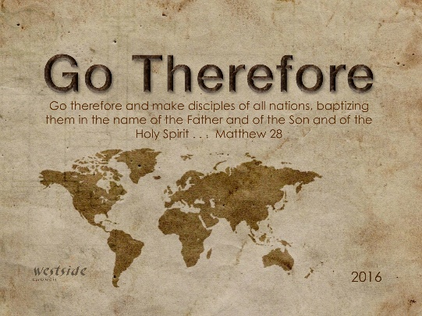
1-15-17
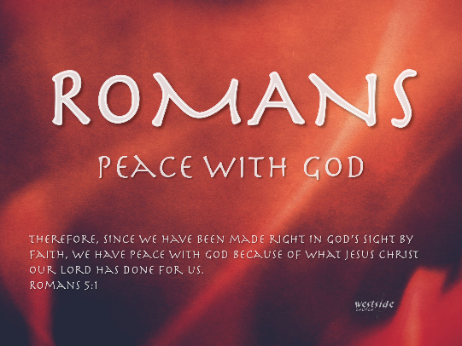

Romans #19
No Longer Slaves

What The Bible Says

Romans 6:15-23
Well then, since God’s grace has set us free from the law, does that mean we can go on sinning? Of course not! ¹⁶ Don’t you realize that you become the slave of whatever you choose to obey? You can be a slave to sin, which leads to death, or you can choose to obey God, which leads to righteous living. ¹⁷ Thank God! Once you were slaves of sin, but now you wholeheartedly obey this teaching we have given you. ¹⁸ Now you are free from your slavery to sin, and you have become slaves to righteous living. ¹⁹ Because of the weakness of your human nature, I am using the illustration of slavery to help you understand all this. Previously, you let yourselves be slaves to impurity and lawlessness, which led ever deeper into sin. Now you must give yourselves to be slaves to righteous living so that you will become holy. ²⁰ When you were slaves to sin, you were free from the obligation to do right. ²¹ And what was the result? You are now ashamed of the things you used to do, things that end in eternal doom. ²² But now you are free from the power of sin and have become slaves of God. Now you do those things that lead to holiness and result in eternal life. ²³ For the wages of sin is death, but the free gift of God is eternal life through Christ Jesus our Lord.

No Longer Slaves

1. No ________________ . . . Yippee!

Romans 6:15
Well then, since God’s grace has set us free from the law
2 Corinthians 3:17
For the Lord is the Spirit, and wherever the Spirit of the Lord is, there is freedom.

John 8:36
So if the Son sets you free, you are truly free.

1 Corinthians 6:12
You say, “I am allowed to do anything”—but not everything is good for you. And even though “I am allowed to do anything,” I must not become a slave to anything.

2. So . . . Who’s My __________________?

Romans 6:16
Don’t you realize that you become the slave of whatever you choose to obey?

WHAT ARE THE CHARACTERISTICS OF OBEDIENCE?
- Willingness (choose)
- ___________________ response (attitude)
- Naturally understanding (tracking)
- Quick to adjust (actions)
  - CHANGE OF HEART: -labc We were wholehearted sinners, even if only in our desires. Now we are to be wholehearted servers, but doing so requires grace, repentance, forgiveness, the Lordship of Christ, the power of the Holy Spirit, restraint of our desires, and disciplined effort.
- Enthusiasm to ___________________ (growth)

3. Yes . . . sometime you gotta ________________ ____!

Romans 6:18
Now you are free from your slavery to sin, and you have become slaves to righteous living.

Romans 6:22
Now you do those things that lead to holiness and result in eternal life.

Joshua 1:8 (ESV)
This Book of the Law shall not depart from your mouth, but you shall meditate on it day and night, so that you may be careful to do according to all that is written in it. For then you will make your way prosperous, and then you will have good success.

James 2:18
Now someone may argue, “Some people have faith; others have good deeds.” But I say, “How can you show me your faith if you don’t have good deeds? I will show you my faith by my good deeds.”

Finally:

4. ________________________ has an eternal 401(k)

Romans 6:23
For the wages of sin is death, but the free gift of God is eternal life through Christ Jesus our Lord.

Romans 6:23 (MSG)
Work hard for sin your whole life and your pension is death. But God's gift is real life, eternal life, delivered by Jesus, our Master.

The degree to which a believer grasps the love of God in justification is the degree to which he is driven to serve God and to live righteously.
-posb

“Now this is eternal life: that they know you, the only true God, and Jesus Christ, whom you have sent.” Here, Jesus equates “eternal life” with a knowledge of God and of the Son.

“Everyone who calls on the name of the Lord will be saved” (Romans 10:13).

Response:

What is God speaking to me?

Specifically, how will I obey Him?

