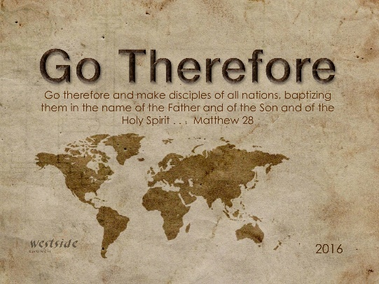
1-22-17
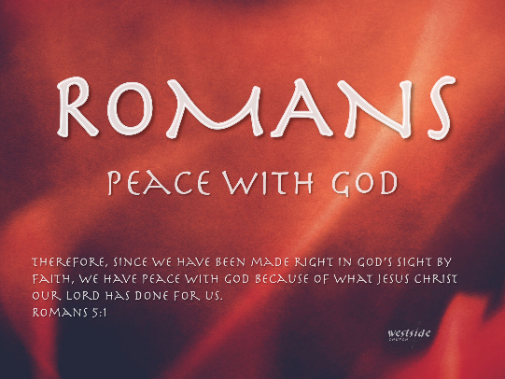

Romans #20
Free To Serve

What The Bible Says

Romans 7:1-13
Now, dear brothers and sisters—you who are familiar with the law—don’t you know that the law applies only while a person is living? ² For example, when a woman marries, the law binds her to her husband as long as he is alive. But if he dies, the laws of marriage no longer apply to her. ³ So while her husband is alive, she would be committing adultery if she married another man. But if her husband dies, she is free from that law and does not commit adultery when she remarries. ⁴ So, my dear brothers and sisters, this is the point: You died to the power of the law when you died with Christ. And now you are united with the one who was raised from the dead. As a result, we can produce a harvest of good deeds for God. ⁵ When we were controlled by our old nature, sinful desires were at work within us, and the law aroused these evil desires that produced a harvest of sinful deeds, resulting in death. ⁶ But now we have been released from the law, for we died to it and are no longer captive to its power. Now we can serve God, not in the old way of obeying the letter of the law, but in the new way of living in the Spirit.

1. Since we are released from the law – we are _______ ___ ______ God.

Romans 7:6
But now we have been released from the law, for we died to it and are no longer captive to its power. Now we can serve God, not in the old way of obeying the letter of the law, but in the new way of living in the Spirit.

Revelation 21:1- 22:21
Then I saw a new heaven and a new earth, for the old heaven and the old earth had disappeared. And the sea was also gone. ² And I saw the holy city, the new Jerusalem, coming down from God out of heaven like a bride beautifully dressed for her husband. ³ I heard a loud shout from the throne, saying, “Look, God’s home is now among his people! He will live with them, and they will be his people. God himself will be with them. ⁴ He will wipe every tear from their eyes, and there will be no more death or sorrow or crying or pain. All these things are gone forever.” . . . ⁹ Then one of the seven angels who held the seven bowls containing the seven last plagues came and said to me, “Come with me! I will show you the bride, the wife of the Lamb.” ¹⁰ So he took me in the Spirit to a great, high mountain, and he showed me the holy city, Jerusalem, descending out of heaven from God. ¹¹ It shone with the glory of God . . . ^{22:1} Then the angel showed me a river with the water of life, clear as crystal, flowing from the throne of God and of the Lamb. ² It flowed down the center of the main street. On each side of the river grew a tree of life, bearing twelve crops of fruit, with a fresh crop each month. The leaves were used for medicine to heal the nations. ³ No longer will there be a curse upon anything. For the throne of God and of the Lamb will be there, and his servants will worship him. ⁴ And they will see his face, and his name will be written on their foreheads. ⁵ And there will be no night there—no need for lamps or sun—for the Lord God will shine on them. And they will reign forever and ever.

¹³ I am the Alpha and the Omega, the First and the Last, the Beginning and the End.” ¹⁴ Blessed are those who wash their robes. They will be permitted to enter through the gates of the city and eat the fruit from the tree of life. ¹⁵ Outside the city are the dogs—the sorcerers, the sexually immoral, the murderers, the idol worshipers, and all who love to live a lie. ¹⁶ “I, Jesus, have sent my angel to give you this message for the churches. I am both the source of David and the heir to his throne. I am the bright morning star.” ¹⁷ The Spirit and the bride say, “Come.” Let anyone who hears this say, “Come.” Let anyone who is thirsty come. Let anyone who desires drink freely from the water of life. ¹⁸ And I solemnly declare to everyone who hears the words of prophecy written in this book: If anyone adds anything to what is written here, God will add to that person the plagues described in this book. ¹⁹ And if anyone removes any of the words from this book of prophecy, God will remove that person’s share in the tree of life and in the holy city that are described in this book. ²⁰ He who is the faithful witness to all these things says, “Yes, I am coming soon!” Amen! Come, Lord Jesus! ²¹ May the grace of the Lord Jesus be with God’s holy people.

Purpose of the Church

1. ____________________ the Bride

2 Corinthians 11:2
For I am jealous for you with the jealousy of God himself. I promised you as a pure bride to one husband—Christ.
Revelation 19:7
Let us be glad and rejoice, and let us give honor to him. For the time has come for the wedding feast of the Lamb, and his bride has prepared herself.

2. __________________ the Nations

Matthew 28:19
Therefore, go and make disciples of all the nations, baptizing them in the name of the Father and the Son and the Holy Spirit.

3. _______________ New Testament Churches Everywhere

- the only New Testament Pattern

4. ______________ – Train – Release Leaders

- elders and deacons are the only offices in the New Testament

5. ___________ ___ a Kingdom of Priests

Ephesians 4:11-13
Now these are the gifts Christ gave to the church: the apostles, the prophets, the evangelists, and the pastors and teachers. ¹² Their responsibility is to equip God’s people to do his work and build up the church, the body of Christ. ¹³ This will continue until we all come to such unity in our faith and knowledge of God’s Son that we will be mature in the Lord, measuring up to the full and complete standard of Christ.

1 Peter 2:9 (ESV)
But you are a chosen race, a royal priesthood, a holy nation, a people for his own possession, that you may proclaim the excellencies of him who called you out of darkness into his marvelous light.

6. ___________________ the Lost

Matthew 9:37-38
He said to his disciples, “The harvest is great, but the workers are few. ³⁸ So pray to the Lord who is in charge of the harvest; ask him to send more workers into his fields.”

So what’s the most important thing we do ?

- Evangelize the lost . . .
- Raise up the priesthood . . .
- Equip & release leaders . . .
- Plant N.T. churches everywhere . . .
- Disciple the nations . . .
- Prepare the church (Christ’s Bride) for His return!

Hebrews 10:23-25
Let us hold tightly without wavering to the hope we affirm, for God can be trusted to keep his promise. ²⁴ Let us think of ways to motivate one another to acts of love and good works. ²⁵ And let us not neglect our meeting together, as some people do, but encourage one another, especially now that the day of his return is drawing near.

Finally:

REMINDER:

Romans 7:6
But now we have been released from the law, for we died to it and are no longer captive to its power. Now we can serve God, not in the old way of obeying the letter of the law, but in the new way of living in the Spirit.

Response:

What is God speaking to me?

Specifically, how will I obey Him?

