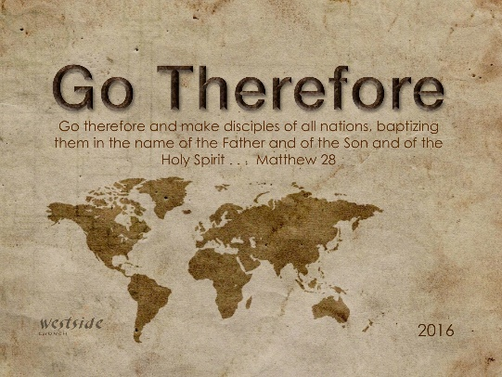
1-29-17
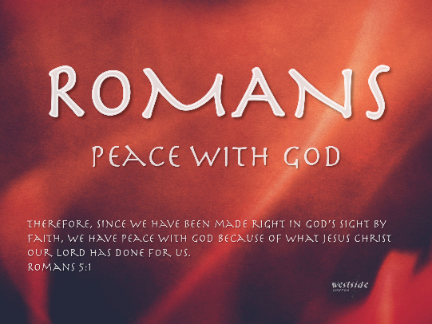

Romans #21

Oh The Struggle

Romans 7:13-25 (ESV)
¹³ Did that which is good, then, bring death to me? By no means! It was sin, producing death in me through what is good, in order that sin might be shown to be sin, and through the commandment might become sinful beyond measure. ¹⁴ For we know that the law is spiritual, but I am of the flesh, sold under sin. ¹⁵ For I do not understand my own actions. For I do not do what I want, but I do the very thing I hate. ¹⁶ Now if I do what I do not want, I agree with the law, that it is good. ¹⁷ So now it is no longer I who do it, but sin that dwells within me. ¹⁸ For I know that nothing good dwells in me, that is, in my flesh. For I have the desire to do what is right, but not the ability to carry it out. ¹⁹ For I do not do the good I want, but the evil I do not want is what I keep on doing. ²⁰ Now if I do what I do not want, it is no longer I who do it, but sin that dwells within me.
²¹ So I find it to be a law that when I want to do right, evil lies close at hand. ²² For I delight in the law of God, in my inner being, ²³ but I see in my members another law waging war against the law of my mind and making me captive to the law of sin that dwells in my members. ²⁴ Wretched man that I am! Who will deliver me from this body of death? ²⁵ Thanks be to God through Jesus Christ our Lord! So then, I myself serve the law of God with my mind, but with my flesh I serve the law of sin.

- The Law is ______________

- Mosaic Law

b. Moral Law of our Hearts

Romans 2:14 & 15 (ESV)
For when Gentiles, who do not have the law, by nature do what the law requires, they are a law to themselves, even though they do not have the law.¹⁵ They show that the work of the law is written on their hearts, while their conscience also bears witness, and their conflicting thoughts accuse or even excuse them

Hebrews 10:1-4 (NLT)
¹ The old system under the law of Moses was only a shadow, a dim preview of the good things to come, not the good things themselves. The sacrifices under that system were repeated again and again, year after year, but they were never able to provide perfect cleansing for those who came to worship. ² If they could have provided perfect cleansing, the sacrifices would have stopped, for the worshipers would have been purified once for all time, and their feelings of guilt would have disappeared. ³ But instead, those sacrifices actually reminded them of their sins year after year. ⁴ For it is not possible for the blood of bulls and goats to take away sins.

c. Why the Mosaic Law?

“The Mosaic Law describes in words the sin we know is in our hearts: making the gospel more relevant and our need for a savior intensely more real.”

2. What is ______?

“Anything that causes the falling short of the perfect and moral law of God and His GLORY! Or is opposed to God.”

- ________________

- ________________

c. ________________

Ephesians 2:3 (ESV)
³ among whom we all once lived in the passions of our flesh, carrying out the desires of the body and the mind, and were by nature children of wrath, like the rest of mankind.

3. Oh, The ___________________

- Flesh vs. Spirit

4. So, ___________ Discuss Sin And Law???

Romans 5:12-21 (ESV)
¹² Therefore, just as sin came into the world through one man, and death through sin, and so death spread to all men because all sinned— ¹³ for sin indeed was in the world before the law was given, but sin is not counted where there is no law. ¹⁴ Yet death reigned from Adam to Moses, even over those whose sinning was not like the transgression of Adam, who was a type of the one who was to come.
¹⁵ But the free gift is not like the trespass. For if many died through one man’s trespass, much more have the grace of God and the free gift by the grace of that one man Jesus Christ abounded for many. ¹⁶ And the free gift is not like the result of that one man’s sin. For the judgment following one trespass brought condemnation, but the free gift following many trespasses brought justification. ¹⁷ For if, because of one man’s trespass, death reigned through that one man, much more will those who receive the abundance of grace and the free gift of righteousness reign in life through the one man Jesus Christ.
¹⁸ Therefore, as one trespass led to condemnation for all men, so one act of righteousness leads to justification and life for all men. ¹⁹ For as by the one man’s disobedience the many were made sinners, so by the one man’s obedience the many will be made righteous. ²⁰ Now the law came in to increase the trespass, but where sin increased, grace abounded all the more, ²¹ so that, as sin reigned in death, grace also might reign through righteousness leading to eternal life through Jesus Christ our Lord.

a. “because it is God’s story for His Glory. His love story about grace and mercy provided to his children through the sacrifice of his very own, Jesus.”

Response:

What is God speaking to me?

Specifically, how will I obey Him?

