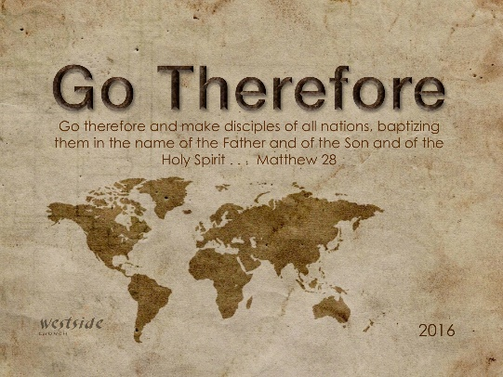
2-12-17

Romans #23

Will Be

What The Bible Says

Romans 8:17-30
And since we are his children, we are his heirs. In fact, together with Christ we are heirs of God’s glory. But if we are to share his glory, we must also share his suffering. ¹⁸ Yet what we suffer now is nothing compared to the glory he will reveal to us later. ¹⁹ For all creation is waiting eagerly for that future day when God will reveal who his children really are. ²⁰ Against its will, all creation was subjected to God’s curse. But with eager hope, ²¹ the creation looks forward to the day when it will join God’s children in glorious freedom from death and decay. ²² For we know that all creation has been groaning as in the pains of childbirth right up to the present time. ²³ And we believers also groan, even though we have the Holy Spirit within us as a foretaste of future glory, for we long for our bodies to be released from sin and suffering. We, too, wait with eager hope for the day when God will give us our full rights as his adopted children, including the new bodies he has promised us. ²⁴ We were given this hope when we were saved. (If we already have something, we don’t need to hope for it. ²⁵ But if we look forward to something we don’t yet have, we must wait patiently and confidently.) ²⁶ And the Holy Spirit helps us in our weakness. For example, we don’t know what God wants us to pray for. But the Holy Spirit prays for us with groanings that cannot be expressed in words. ²⁷ And the Father who knows all hearts knows what the Spirit is saying, for the Spirit pleads for us believers in harmony with God’s own will. ²⁸ And we know that God causes everything to work together for the good of those who love God and are called according to his purpose for them. ²⁹ For God knew his people in advance, and he chose them to become like his Son, so that his Son would be the firstborn among many brothers and sisters. ³⁰ And having chosen them, he called them to come to him. And having called them, he gave them right standing with himself. And having given them right standing, he gave them his glory.

1. Lots Of ________________ Going On

Romans 8:22
For we know that all creation has been groaning as in the pains of childbirth right up to the present time.

- creation groans
- believers groan
- the Spirit groans

It is not the groaning of hopelessness, but the sound of total concentration on a painful, but hopeful conclusion. It is not the despairing cry of the hopeless, but the eager longing of the hopeful.
-labc

2. ______________________ Anticipating

Romans 8:23
And we believers also groan, even though we have the Holy Spirit within us as a foretaste of future glory, for we long for our bodies to be released from sin and suffering. We, too, wait with eager hope for the day when God will give us our full rights as his adopted children, including the new bodies he has promised us.

- we were given this hope when we were saved . . .
- we must wait patiently and confidently . . .

3. In The Strength Of His ________________

Romans 8:26a
And the Holy Spirit helps us in our weakness.

How?
- by interceding for us

Romans 8:26b-27
And the Holy Spirit helps us in our weakness. For example, we don’t know what God wants us to pray for. But the Holy Spirit prays for us with groanings that cannot be expressed in words. ²⁷ And the Father who knows all hearts knows what the Spirit is saying, for the Spirit pleads for us believers in harmony with God’s own will.

Our Prayer Mandate:
- in harmony with the will of God

4. Were – Are - Will

we were saved – are being saved - will be saved

__________ ___________ __________

Romans 8:30
And having chosen them, he called them to come to him. And having called them, he gave them right standing with himself. And having given them right standing, he gave them his glory.

God's foreknowledge does not imply determinism:
the idea that all our choices are predetermined.
-labc

Finally:

REMINDER: ________________ is our only hope!

Colossians 1:27 (ESV)
To them God chose to make known how great among the Gentiles are the riches of the glory of this mystery, which is Christ in you, the hope of glory.

Colossians 1:27 (NLT)
For God wanted them to know that the riches and glory of Christ are for you Gentiles, too. And this is the secret: Christ lives in you. This gives you assurance of sharing his glory.

The hope of glory is the fulfillment of God’s promise to restore us and all creation. This hope is not a wishful thought, but the confident, expectant, joyful knowledge that we are being changed by God and will one day see Christ face to face, having been conformed to His image.

Response:

What is God speaking to me?

Specifically, how will I obey Him?

