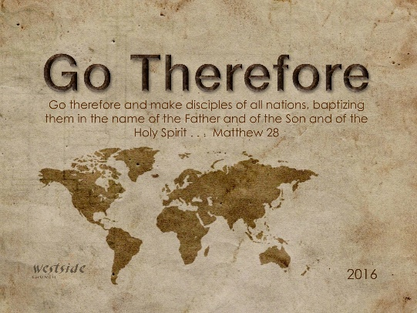
2-19-17
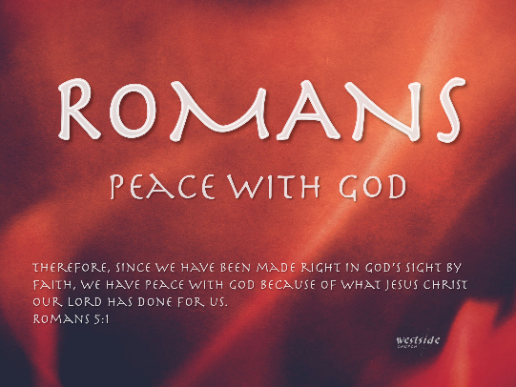

Romans #24

Romans 8

Romans 8:31-39 (ESV)
³¹ What then shall we say to these things? If God is for us, who can be against us? ³² He who did not spare his own Son but gave him up for us all, how will he not also with him graciously give us all things? ³³ Who shall bring any charge against God’s elect? It is God who justifies. ³⁴ Who is to condemn? Christ Jesus is the one who died—more than that, who was raised—who is at the right hand of God, who indeed is interceding for us. ³⁵ Who shall separate us from the love of Christ? Shall tribulation, or distress, or persecution, or famine, or nakedness, or danger, or sword? ³⁶ As it is written, “For your sake we are being killed all the day long; we are regarded as sheep to be slaughtered.” ³⁷ No, in all these things we are more than conquerors through him who loved us. ³⁸ For I am sure that neither death nor life, nor angels nor rulers, nor things present nor things to come, nor powers, ³⁹ nor height nor depth, nor anything else in all creation, will be able to separate us from the love of God in Christ Jesus our Lord.

Main Points

- If God is for us, who can be against us?

  - God sacrificed his son so that we can have life with him.
Romans 5:6-8 (ESV)
⁶ For while we were still weak, at the right time Christ died for the ungodly.
⁷ For one will scarcely die for a righteous person—though perhaps for a good

person one would dare even to die—⁸ but God shows his love for us in that while we were still sinners, Christ died for us.

- Who dares accuse us whom God has chosen for his own?

  - No one. God has given us right standing with himself.

  - If we have put our trust in Jesus, God does no longer keeps a record against us. We are justified.

1 Corinthians 6:9-11 (ESV)
⁹ Or do you not know that the unrighteous will not inherit the kingdom of God? Do not be deceived: neither the sexually immoral, nor idolaters, nor adulterers, nor men who practice homosexuality, ¹⁰ nor thieves, nor the greedy, nor drunkards, nor revilers, nor swindlers will inherit the kingdom of God. ¹¹ And such were some of you. But you were washed, you were sanctified, you were justified in the name of the Lord Jesus Christ and by the Spirit of our God.

- Who then will condemn us? - No one.

  - Christ Died
    - Christ paid the price for our sins

  - He rose
    - God was fully satisfied

Romans 4:22-25 (ESV)
²² That is why his faith was “counted to him as righteousness.” ²³ But the words “it was counted to him” were not written for his sake alone, ²⁴ but for ours also. It will be counted to us who believe in him who raised from the dead Jesus our Lord,
²⁵ who was delivered up for our trespasses and raised for our justification.

  - We identify with Christ’s death and Resurrection through baptism.
Colossians 2:12 (ESV)
¹² having been buried with him in baptism, in which you were also raised with him through faith in the powerful working of God, who raised him from the dead.
  - And He sits at the right hand of God interceding for us.
Romans 8:11 (ESV)
¹¹ If the Spirit of him who raised Jesus from the dead dwells in you, he who raised Christ Jesus from the dead will also give life to your mortal bodies through his Spirit who dwells in you.

- Can anything ever separate us from Christ’s love?

  - Does it mean that He no longer loves us if we have trouble, calamity, or are persecuted, or hungry, or destitute, or in danger, or are threatened with death?

  - vs37 No, in all these things we are more than conquerors through him who loved us.

  - ³⁸ For I am sure that neither death nor life, nor angels nor rulers, nor things present nor things to come, nor powers, ³⁹ nor height nor depth, nor anything else in all creation, will be able to separate us from the love of God in Christ Jesus our Lord.

John 16:26-27 (ESV)
²⁶ In that day you will ask in my name, and I do not say to you that I will ask the Father on your behalf; ²⁷ for the Father himself loves you, because you have loved me and have believed that I came from God.

Take Away

- We can have confidence that we have relationship with God.

  - He sent his son to die and rise again, so that we can be made right with him.

  - When we fix our hope in Jesus we have everlasting life.

  - Nothing can separate us from Gods love.

Response:

What is God saying to me?

Specifically, how will I obey Him?

