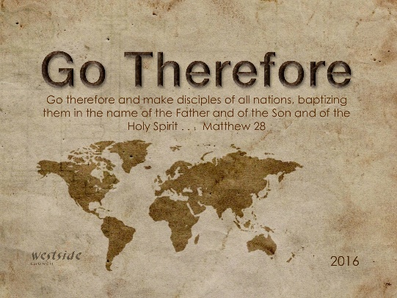
2-5-17
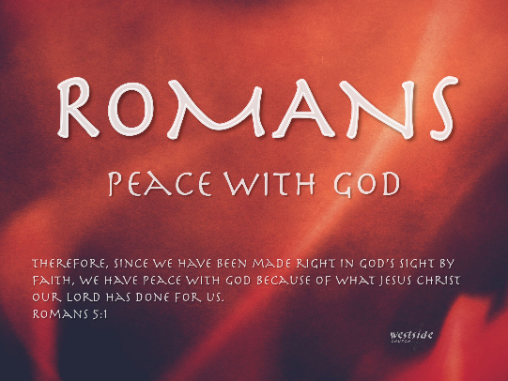

Romans #22
Lead By The Spirit

What The Bible Says

- The question arises,
  - Are we to spend our entire lives defeated by sin?
- The answer is a resounding NO!

Romans 7:25
Thank God! The answer is in Jesus Christ our Lord. So you see how it is: In my mind I really want to obey God’s law, but because of my sinful nature I am a slave to sin.

Romans 8:1-16
So now there is no condemnation for those who belong to Christ Jesus. ² And because you belong to him, the power of the life-giving Spirit has freed you from the power of sin that leads to death. ³ The law of Moses was unable to save us because of the weakness of our sinful nature. So God did what the law could not do. He sent his own Son in a body like the bodies we sinners have. And in that body God declared an end to sin’s control over us by giving his Son as a sacrifice for our sins. ⁴ He did this so that the just requirement of the law would be fully satisfied for us, who no longer follow our sinful nature but instead follow the Spirit. ⁵ Those who are dominated by the sinful nature think about sinful things, but those who are controlled by the Holy Spirit think about things that please the Spirit. ⁶ So letting your sinful nature control your mind leads to death. But letting the Spirit control your mind leads to life and peace. ⁷ For the sinful nature is always hostile to God. It never did obey God’s laws, and it never will. ⁸ That’s why those who are still under the control of their sinful nature can never please God. ⁹ But you are not controlled by your sinful nature. You are controlled by the Spirit if you have the Spirit of God living in you. (And remember that those who do not have the Spirit of Christ living in them do not belong to him at all.) ¹⁰ And Christ lives within you, so even though your body will die because of sin, the Spirit gives you life because you have been made right with God. ¹¹ The Spirit of God, who raised Jesus from the dead, lives in you. And just as God raised Christ Jesus from the dead, he will give life to your mortal bodies by this same Spirit living within you. ¹² Therefore, dear brothers and sisters, you have no obligation to do what your sinful nature urges you to do. ¹³ For if you live by its dictates, you will die. But if through the power of the Spirit you put to death the deeds of your sinful nature, you will live. ¹⁴ For all who are led by the Spirit of God are children of God. ¹⁵ So you have not received a spirit that makes you fearful slaves. Instead, you received God’s Spirit when he adopted you as his own children. Now we call him, “Abba, Father.” ¹⁶ For his Spirit joins with our spirit to affirm that we are God’s children.

This is one of the most important passages in all of Scripture. Its subject cannot be overemphasized:
the power of God's Spirit in the life of the believer.
If the believers need anything, . . .
they need the power of God's Spirit.
-posb

1. No ____________________!

Romans 8:1
So now there is no condemnation for those who belong to Christ Jesus.

satan’s two weapons:
- he is a ____________
- he is the _______________

1 John 3:19-20
Our actions will show that we belong to the truth, so we will be confident when we stand before God. ²⁰ Even if we feel guilty, God is greater than our feelings, and he knows everything.
There is therefore now no condemnation
to those who are in Christ Jesus!

2. AND you are ________________!

Romans 8:2
And because you belong to him, the power of the life-giving Spirit has freed you from the power of sin that leads to death.

The Spirit of life is the _____________ ______________

- Who was present at the creation of the world
- He is the power behind the rebirth of every Christian
- The Holy Spirit sets us free

How did this happen?
First, this law of the Spirit set you free

Second, after we are free, "the Spirit of God lives in" us (verse 9)

3. Life or _____________?

Romans 8:12-14
Therefore, dear brothers and sisters, you have no obligation to do what your sinful nature urges you to do. ¹³ For if you live by its dictates, you will die. But if through the power of the Spirit you put to death the deeds of your sinful nature, you will live. ¹⁴ For all who are led by the Spirit of God are children of God.
Paul divides people into two categories—those who let themselves be controlled by their sinful nature and those who follow after the Holy Spirit. We would be in the first category if Jesus hadn't offered us a way out. After we say yes to Jesus, we want to continue following him because his way brings life and peace. We must consciously choose to center our life on God.
-labc

4. How we can be led by the Spirit?

2 Samuel 24:24 (NIV)
"No, I insist on paying you for it. I will not sacrifice to the Lord my God offerings that cost me nothing."

Ideas:
- Ask for ______________
- Walk in _________________
- Look to His _________
- ______________ – get moving

When was the last time you prayed as Jesus did, "Nevertheless, may your will, not mine, be done"?

Finally:

Romans 8:15
So you have not received a spirit that makes you fearful slaves. Instead, you received God’s Spirit when he adopted you as his own children. Now we call him, “Abba, Father.”

Response:

What is God speaking to me?

Specifically, how will I obey Him?

